

FREIE UNIVERSITÄT BERLIN
School of Business and Economics
Department of Management

Public Policy and Climate Change

Seminar essay in the seminar 0171dB2.6.1
„Quantitative Methoden“

Summer Term 2023

Submitted to
Prof. Dr. Ana Tur Prats
07/14/2023

By:
Sebastián Sifontes Valentín.
Mail: sebastiansvsv@gmail.com
Study program: Economics and Public Administration, 8th semester.
Immatriculation number: 5574278.
Number of words: 7073 words.
Index

Contents

Part 1: Motivation and Introduction............…………………...…………….……3 to 4
Part 2: Background…………........……….….……………………………............4 to 6
Part 3: Analysis............…………………...…………….………………………….6 to 14
Part 4: Conclusions…………........……….….……………………………...........14 to 15
Part 5: Appendix…………………………………………………………………….16 to 17
Part 6: References………………………………………………………………….18 to 20
Figures
Figure 1: Global Greenhouse Gas Emissions by emissors. 2020………….…………….4
Figure 2: Global Greenhouse Gas Emissions from Food Production. 2018…………...7
Figure 3: Global Land Use for Food Production. 2013…………………………………….7
Figure 4: Share of total expenditure and share of total GHG emissions by category for an average household……………………………………………………………………….8
Figure 5: Assessment Tool to Estimate CO2 Emissions of Pavement Production and Construction. 2021…………….……………….…….……………………...………..……..9
Figure 6: Size of Fossil Fuel Subsidies. 2022…………………………………………….12
Figure 7: Climate Action Tracker. The CAT Thermometer. (2022)…………………….16
Figure 8: Distribution of emissions based on worldwide production and consumption among these four income levels, as well as global population. 2019…………………..17

Affidavit

I, Sebastián Sifontes Valentín, hereby certify that I have created this essay independently and to the best of my knowledge and belief. Any help that I have received in my research work and the preparation of the essay itself has been acknowledged. I have indicated all information sources and literature used in the essay. I am aware that for any internet sources used I must include the date of access as well as the internet address (URL) in the reference list. Furthermore, I agree with the usage of scanning software to detect plagiarism. My essay has not been submitted otherwise.

Berlin, 14 of July 2023.

Motivation:

Since I decided to begin my studies in Economics, I have always had and will always have the intention of being able to positively affect the world with my job research for helping our societies achieve greater prosperity, anticipating effectively the problems or situations that have always arisen and will always arise.

In this case, I see this as my first opportunity to take a step further in being able to contribute empirically to this change, trying to clarify that climate change is not being addressed with what is necessary to reverse it so far, and that there are still possible ways to offer our current generations simultaneously a stable planet along with sustainable economies.

Introduction

For a long time now, we as citizens have been aware, to a greater or lesser extent, of climate change, and how it could definitely change our way of life if we do not do something to stop it. From the media we hear how, for example, areas are flooded that supposedly should not be like this, or intense heat waves that last longer and are increasingly hotter, among many other statements, making us wonder about how this situation can be reversed, what things are being done by governments to avoid the most fatalistic predictions, or what role do I as a citizen play in these events, would a drastic change in my lifestyle really make a significant contribution to counteracting climate change?.

It is for this reason that this research attempts, on the one hand, to compile several leading academic works that address answers to these kinds of questions, and this is key when assuming that choosing the economics way to interpret this issue is the correct way to provide us with the answers we are looking for. Once the proposals of these projects have been identified, the analytical part of my research will address alternative answers, arguing that there are different actors within the global pollution emitters, and consequently, we must clarify these actors for then moving forward on to propose feasible and realistic solutions to this problem. Specifically, three actors have been wisely chosen for proposing solutions with a relevant impact in case governments take more care about those, and these are the macro-farms, households, and the concrete industry, as you can find in the following diagram:

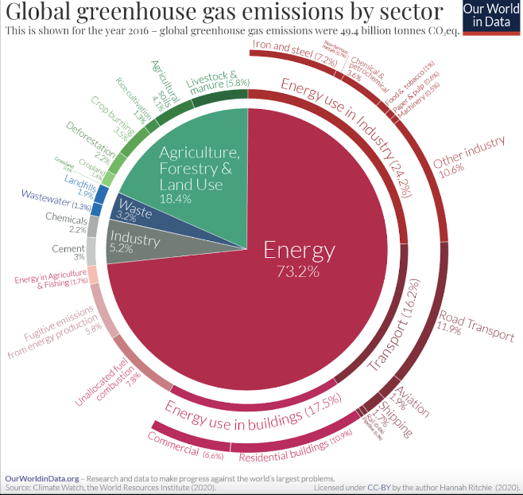

Figure 1: Ritchie et al. 2020.

Getting deeper into the analytical work, certain arguments are offered for justifying why governments have the most power to change global emissions trends, and is also considered that this topic, by its nature, does not have a single answer to solve the problem, but is about a broad set of interrelated actors, where all play their part and have their weight when talking about greenhouse gas emissions; therefore, governments around the world need to take this and other empirical assertions into account when implementing any public policy in this context.

Finally, for giving proper solutions to the inquires proposed in the beginning, the immediate need to propose and promote new public policies is highlighted, since, if we were to continue in a future scenario with the current global policies, even in the most favourable scenario, climate change would affect our way of life drastically, a position that we should try to avoid, if we consider that countries want to have prosperous economies and the world's population is growing more and more; as you can find during this paper, these two facts are two of the highest general dares that we have to face, for finding a general point between economic prosperity and greenhouse gases emissions, but also possible problems coming from the solutions here offered are also considered, as depending on the economic development of the country, the application of the public policies may vary depending on that main condition.
Changes are necessary and unavoidable if we want to avoid such drastic scenarios.

Background

The quoted research articles and books talking about public policy and climate change topic either partially, or entirely, have in both cases interesting points of view when trying to solve this issue.
Particularly, in a historical point of view, we must consider two key scenarios about having countries trying to reach common agreements for fighting climate change: Kyoto Protocol (2003) and The Treaty of Lisbon (2009), as both moments brought about notable changes in terms of certain policies, at the global or European level, or on the other hand, prompted theorizing about new ways of understanding and coping with climate change.
Furthermore, policy solutions are often focused on the energy sector, and the main reason is due to the high influence this sector has over the climatic impact, a 73,2%
(Ritchie et al. 2020), and it is worth noting that, since the Kyoto Protocol, one of the contributions of the economists of the time has been on the Kaya indicators, where economist Yoichi Kaya established four indicators (Yoichi Kaya and Keiichi Yokobori, 1997), two of them being the main reasons he considered direct causes of climate pollution, namely economic growth and population size, closing his proposal by giving two indicators, labeled by global carbon footprint and energetic intensity, respectively, in which he identifies as possible solutions to stop our CO₂ emissions trend.
In this research, we focus on the latter two, as Kaya's proposal is differential, in that it considers the possible repercussions of achieving greater energy efficiency, since we run the risk that, firstly, after achieving greater energy efficiency, we also use more energy, demanding more energy than when it was less efficient, and then, although this first assumption is not fulfilled, by being more efficient, we could end up increasing our levels of CO₂ emissions as this efficiency allows for certain savings, which can end up being invested in things that would not have been consumed without these savings, e.g., the increase in demand for airline tickets in the United States as the efficiency of this mode of transport evolved, or how savings on petrol after buying an electric car can end up being used to buy airline tickets for a short getaway.
Turning now to the Lisbon Treaty, among the decisions taken at that time, it is worth mentioning both the approval of the reduction in nuclear energy and the attempt to promote investment in greener technologies, since from this point onwards energy policy was established as a Europe-wide problem by law (Peter, 2016).
In order to allow this paper to give an update on what is proposed within the economic discipline, it is worth summarizing that these two treaties gave rise to more alliances over the years, which allow us to see today that several countries worldwide are tending to take the right path to counteract the effects, such as the G20, which allows for multilateralism between North America, Europe and Asia on generic agreements, or the multiple European associations derived from the Lisbon treaty, such as the European Green Deal (EGD), where research funds were promoted for getting the Research and Experimental Development (R&D) (Henri Delanghe & Ugur Muldur 2014), that basically leads to technological innovation, the European Atomic Energy Community (Euratom), to coordinate nuclear energy research programmes, or the 2030 Agenda, where it is expected to reduce greenhouse gases by 55% and to be carbon or fossil fuel neutral by 2050 (Jörg Kemmerzell et al. 2022).
Even so, considering all the above mentioned agreements, together with many others that are yet to be reviewed, more in a global sense, we can affirm that the climate change debate is being given the wrong environment, or at least unfocused (Henri Delanghe & Ugur Muldur 2014), by not fundamentally considering the inequity generated by certain public policies following the Stoper-Samuelson theory, which establishes that the greater the climate protection, the greater the economic inequity that can also be produced.
Although it is not one of the points to be resolved in this work, it is worth highlighting in the sense that a public policy proposal that affects more than one country could generate, especially in developing countries, a much larger inequity gap, where countries that play a large role in the current distribution of countries that distribute energy, such as Turkey, Vietnam or Indonesia, are considered as susceptible to this phenomenon.
In summary, although there are countries that are currently characterized by representing great progress towards a stable path towards reducing the effects of climate change on our planet, such as France's transition to nuclear energy, or the recent changes in China also in this regard, different proposals are required, capable of solving the challenges posed by the different polluting agents of our entire industrial framework, we would be within a stable objective in an extremely optimistic case, being a fact that current policies will not achieve the necessary objectives to avoid climate change, and therefore, we need to implement new policies.

Analysis

Following the truism established in the theoretical framework, we must apply new solutions, in addition to the existing ones, for reaching, at least, a more favourable scenario already at the end of our century. For this reason, this research is focused on three areas which are not usually located within the bulk of economic research, that are relevant when checking the overall emissions of CO2 per year, and therefore, these problems should be better described for subsequently offering feasible solutions to them for being able to reach that change, or goals levels for avoiding the worst scenarios.

Before getting into detailed problems and solutions about these three areas, is necessary to digress to highlight the vital importance of governments to counteract climate change for reducing the “media burden”, still present on individual lifestyles. Delving into the data used to produce this research, in first place, we can find that, when comparing global per capita emissions (of around 5 million tons of CO₂ in 2017), with the emissions of the global energy sector, having an individual eliminating 100% of their emissions for the rest of it is life, it would be saving one second’s worth of emissions from the global energy sector, making even the most motivated person not getting able to make a tiny dent¹; of course, this data varies if we swipe the focus from country to country, but the difference between the values obtained from the calculations of the emissions from a sample of different countries with different levels of annual per capita emissions, and different life expectancies, makes this generic statement more conclusive. This is a key argument for understanding the importance of governments, via public policy, as they would have the greatest impact on reversing climate change.

After briefly understanding why people on their own cannot make a big change after adapting their lifestyles to a more environmentally conscious one, but rather it is in the hands of governments, we can establish in the first instance, the three areas and why these suppose a problem for the environment as it follows:

- Macro-farms, as they are responsible for a quarter of the world's greenhouse gas emissions (a 26% specifically), mainly because meat has become a staple food over time, being responsible of 57% of the food sector's CO₂ emissions, as you can see in the figure 2, and meanwhile, approximately 40% of the habitable territory on Earth is used for meat production, and that is equivalent to the whole territory of the American continent. Keeping the trending emissions from the current food system, according to predictions made by the World Resources Institute (WRI), is not sustainable for the increasing needs we will have for the year 2050², requiring in consequence, some differential changes for trying to reduce the sector's 26% influence on global emissions.

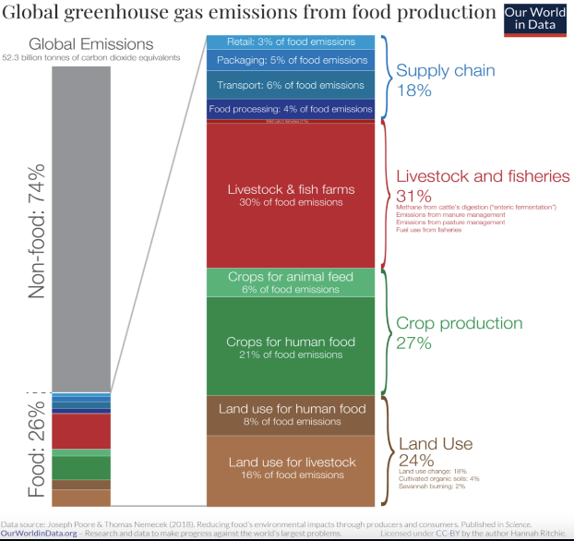
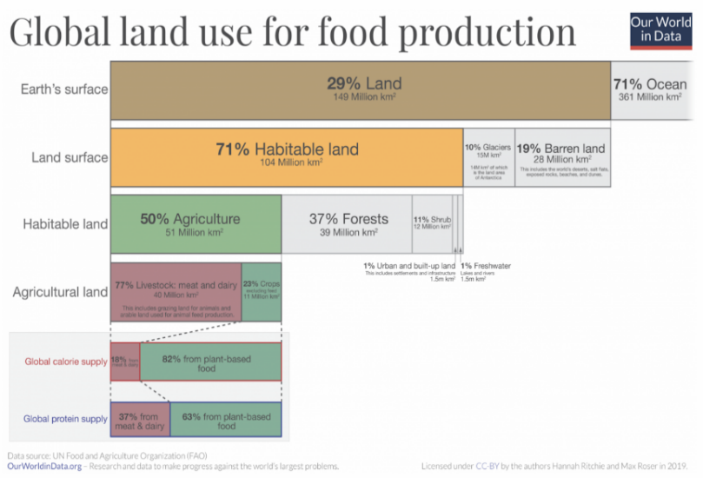
Figure 3: Ritchie & Roser (2013)

Figure 2: Joseph Poore & Thomas Nemecek (2018)

From the data presented here, it is a fact that by reducing the demand for meat, we would not achieve an impact by itself, noticing that there are many more causes with a similar influence on the total CO₂ emissions of the sector, e.g., the already mentioned usage of lands, or the huge impact coming from the supply chain; even into the general meat consumption, is a reality that the principal emissors are coming from the fisheries, since it generates many negative externalities such as spilling fossil fuels into the oceans, or helping to increase plastic pollution in the oceans.
Obtaining the goal emission reductions from this cause alone, requires extreme and unrealistic changes in consumption trends for offering solutions for the year 2050, where, due to population growth trends alone³, we will require more food to feed the population and the urgency of having to reduce CO₂ emissions.

- Households: In particular, the impact from this sector is coming from all the energy demanded by the households, specifically for electricity generation for lighting, appliances, cooking, domestic heating, etc... Why this actor has such relevance is due the CO₂ it generates in a year, is greater than the total emitted by all cars⁴. Indeed, they are emitting approximately 5400 tons of CO₂ vs. 3500 tons generated by passenger car journeys⁵, so the emission from household is namely explained by the energy demand, but that is not the only cause:

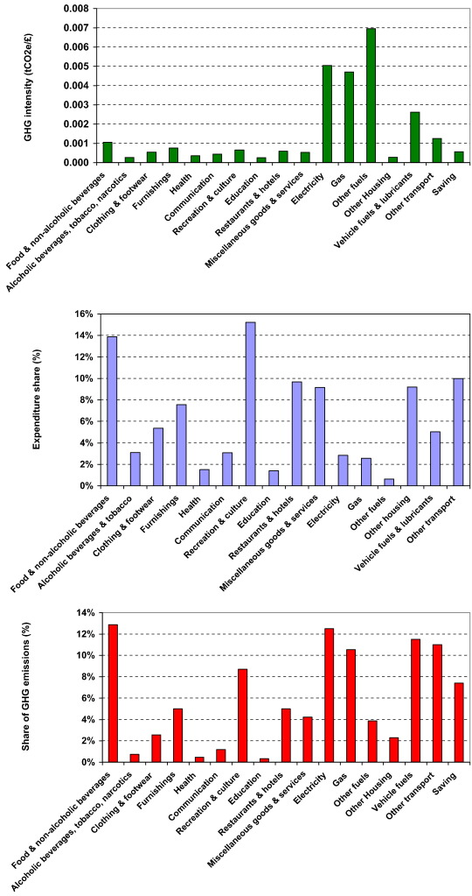

Figure 4: Chitnis et al. 2014

As described in the Chitnis et al., 2014 study from the UK households, from the graph above we can find that direct energy consumption only accounts for 41% of an average household's ‘GHG footprint’ (divided between 29% domestic energy i.e. electricity, gas and other fuels and 12% vehicle fuels); among the categories that stand out the most and are not generated by energy consumption are, firstly, the category providing the largest single contribution to total emissions for an average household is food and non-alcoholic beverages (14%), but also the proportion coming from recreation and culture, or furnishings. This study is representative when considering possible solutions to this problem, that would also help to solve problems coming from other sectors.

- Concrete industry, as it is responsible for 8% of global CO₂ emissions into atmosphere⁶. Related to the second point and to how construction of roads, bridges, houses, etc. are carried out, as this material is an old reliable in the construction industry, and it is not difficult to produce while being inexpensive simultaneously, helping the process of building cheaper households, in either developed countries, main European capitals that are trying to face the increasing evolution of rent prices in their cities, or countries like China, considered as a high-income country (by World Bank ranking), still depends on this material for building up roads and structures for more than 1.4 billion of people.

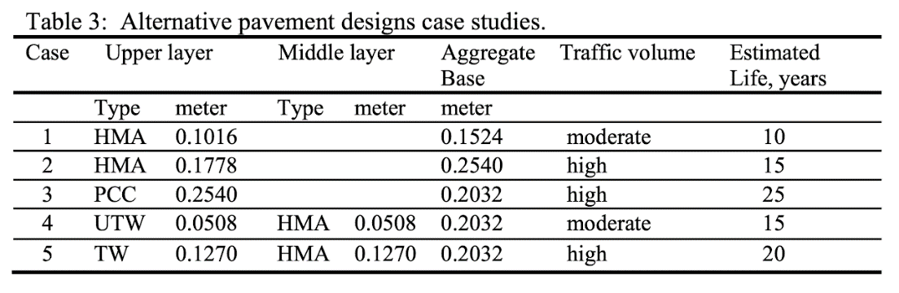

Figure 5: Kamil E. Kaloush et al., 2021

Above in the data is shown that the CO₂ emissions on the five cases are between 14.6 and 26.3 tonnes per kilometre, per year, over their lifetime of 10 to 25 years (Kamil E. Kaloush et al., 2021), representing huge levels of emissions for that considered period of time.

Is necessary to consider beforehand that, among the options of cutting-edge technology in terms of energy sources, into this project is also considered three possibilities, as promising alternatives ways of producing energy: CO₂ capture, tidal power and biofuel derived from marine algae stand out; more will be said about these new technologies later, but the idea so far is to make it clear that we already have real possibilities to invest in for the governments, as they have tremendous potential, and could be really helpful for developing the solutions proposed later, and so, the relationship between this new energy alternatives and the three actors will be stated also later.

Returning to the issue of public policy, within the menu of specific solutions for the three areas addressed in this research, is stated:

  - Among the macro-farms, when considering either Figure 2 and Figure 3 provided above, solutions in this regard are based on the parts of the food sector that have the most influence on the overall emissions emitted by this sector. This is why, in pure emissions terms, a feasible solution would be to optimize, in one hand, the 40% of the total land taken up, reducing it as much as possible by promoting the development of extensive animal husbandry regimes, lowering the proportion destined to feed animals, the vast majority of which are under intensive regimes, and combined with a simultaneous action on the demand side, could end up with a favorable scenario for restoring certain native ecosystems such as the Amazon rainforest, generating a positive impact as it would be a natural way to help the planet taking care of the greenhouse gases. A practical example fitting this solution model are the land-based seaweed farms, as it is a food capable of providing many nutrients and proteins capable of replacing meat in vegetarian or vegan diets, while it is not complicated to develop and does not require artificial additives.
In the other hand, from the demand side, intuitively we can think that seeking to reduce the demand for meat must be one of the main goals from governments as it would help to cut down the total emissions of the food sector, and an efficient way to achieve this goal, while not applying an abrupt or sudden change in the consumption trends of the individuals would be to progressively promote research, development and implementation of meat substitutes in the population, such as lab grown or cultured meat, that costs from 6 to 12 times less CO₂ to produce than raising a cow⁷, but as it is going to be discussed in the general solutions, the cultured meat is currently competitive in emissions with cattle systems, making it incompatible with the current climate goals and is mainly caused by the demand trends of meat, and its ways of obtaining energy for manufacturing the lab meat, so is a current uncertain idea that the cultured meat is the real alternative to the cattle systems, while at the same time, further research allowing this new technology to evolve by time will help to clear up this overview.
Also, when the fish farms got highlighted into the problems was due this sector has many of its emissions coming from the transport methods that are taking use of classic fossil fuels, so being able to propose real alternatives to this fossil fuels will also have a significant impact reducing the pollution generated by the meat sector (see at the end of the Analysis the Biomass Fuels description).
This last comment is key for stating that, pretending to have such sudden changes in the demand of meat from the society seems unrealistic for reaching the goals agreed in the 2050 objectives from European commission, but the food sector has other parts with significant contribution to the global pollution, that could have more immediate solutions, while the slow introduction and progressive improvement of meat alternatives will allow us to slightly change the demand trends of meat consumers.

2.1. Regarding households, a viable solution lies in stipulating energy efficiency standards when building new homes, but derogating from these new standards also requires alternatives to be offered to enforce them, so it is key to consider technological developments in energy and construction, for making household consumption and emissions more responsible and reduced. As for existing households, it would also be beneficial to implement incentives for citizens to invest in sustainable energy systems for their own home, and thus indirectly reduce energy consumption; in fact, a public policy focused on rewarding and/or helping a homeowner to invest in installing solar panels on their property, would have a significant positive impact in the global households emissions, making it possible to dispense partially or totally with the need to demand energy from energy suppliers that distribute energy produced by traditional methods. In this sense, the proposal will be set out in great detail, as there have already been attempts to implement this policy, mostly unsuccessfully, mainly because of the failure to provide sufficient incentives to motivate consumers to make this change.

The aim is to benefit, on the one hand, the citizen with immediate and realistic incentives, but without avoiding the energy firms. Following the example given above, the incentive to invest for the homeowners can take the form of a direct subsidy at the time of purchasing and installing the solar panels, or it can provide significant indirect benefits for citizens, such as tax benefits when filing their income tax returns for generating a positive impact on the environment, depending on the specific situation of a country, many ways of promoting this goal are possible.

On the part of the energy companies, when the importance of promoting research and application of new technologies within the sector was indicated, it is to achieve, while promoting the demand for new ways of generating energy, marketers also look for ways to do business within this system, thus promoting a sustainable way of creating energy for households. The transition to new ways of generating energy for households, together with the alternatives offered by the government, would at least make the transition to new ways of generating energy for households a reality insofar as, with this induced change in demand, the supply side will seek to offer new alternatives with new prices to remain in the market. It is also the role of the state to take care of its business network.

To close the part of public policy proposals for the specific problems:

3.1. When talking about the concrete industry, it is key to promote public policies capable of promoting the transition towards sustainable concrete, as well as in the direction of possible alternatives to it with less impact on emissions, and once an alternative is feasible, the aspect of sanctions, should be focused on progressive increasing restrictive sanctions against the traditional production method over time, in order to reduce that 8% of global CO₂ emissions. Public policies focused on the construction of new public infrastructure can give priority to contractors working with more sustainable construction methods, which, although difficult to compete on cost, require simultaneous investment in sustainable concrete to lower the costs of the sustainable method via demand. As one of the alternatives for developing a transition on this area, it follows:

    - Green Concrete: “Scientists at a British concrete manufacturer, the London-based Novacem, claim to have developed a new form of concrete that effectively absorbs large amounts of carbon dioxide as it hardens. Novacem's new version of concrete, uses a different raw material, magnesium sulphate, which requires much less heating. Novacem claim that each tonne of cement can absorb up to 0.6 tonnes of CO₂. This is opposed to figures that claim that each tonne of old-style cement emits about 0.4 tonnes of CO₂.” The main problem is that this proposal, although it has been one of the most prominent, its proposal was carried out more than ten years ago, and it was never able to raise the necessary funds to develop it. Therefore, although the best solution would always be an evolution capable of counteracting the current difficulties, that is the reason why this research encourages, at the end of the analysis, that governments must redirect subsidies to this type of technological investment.
Likewise, the most immediate responses, considering the current knowledge, is on one side, the capacity to use the processed CO₂ captured by the CO₂ capture, as reinforcement materials for cement in construction (their operation is detailed at the end of the analysis), or with plastics, instead of the classic steel reinforcements⁸; on the other side, making use of concrete derived from the demolition of other buildings, by establishing a recycling procedure for this material, is a real possibility to consider. Also, one of the most polluting parts of concrete manufacturing is the high temperatures required to develop it, so the energy production proposals proposed below could help the traditional concrete manufacturing process to have less impact by using renewable energies for its production process.

As mentioned across the solutions for the three actors, after giving a look at each solution, it is possible to appreciate a general trend regarding, and requiring the role of the state in implementing this and other public policies on climate change, implying that the governments should aim to find out how to start with solutions capable of encompassing the largest number of specific actors within the overall picture, in order to make the leap to offering public policies with a more generic character. In view of this, from the general context, the most noteworthy decisions that governments should take for running policies against climate change, but specifically among the three actors are both penalties and subsidies.
When talking about proposals for penalties, those are mainly focused on the price on CO₂, aimed over, of course, the big emitters of CO₂, which must get worsen over time, as well as allocating subsidies to investment both in new energy production alternatives, and in further promoting the development of existing technologies e.g., allowing nuclear plants to run on CO₂, are the main influencing tools that governments have at their disposal to achieve positive environmental impact.
Under the heading of subsidies, it is worth highlighting that governments currently allocate more to the oil and gas sectors, and this is mainly explained due it generates a cycle capable to get lower transport costs, having a direct impact on lower prices of consumer goods, generating in consequence, political lobbies in favour of subsidizing fossil fuels⁹, being the main reason of why changing the issue of subsidies requires to be able to achieve for example, prices of consumer goods, in particular food, at more affordable prices, and that is one of the many main challenges that the meat alternatives have to face.

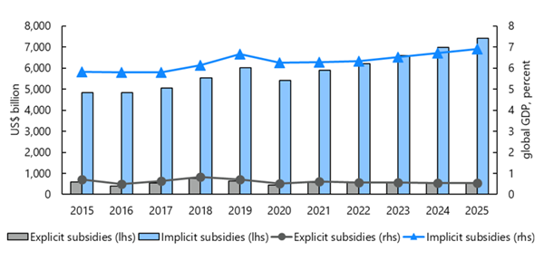
Figure 6: IMF, 2019.

It is feasible counteract this tendency of governments to invest that much in fossil fuels through alternative ways of energy production that will have a direct positive effect, not only over the solutions here proposed for the three actors, but also in the general landscape of pollutants. The main description of how they work, and also the principal reasons backing up this idea are:

- CO₂ capture: This is a technology that directly captures CO₂ from the atmosphere, for then, in one hand, store it in deep geological formations or, in the other hand, can use the CO₂ in the production of fuels, chemicals, building materials, or as is pretended in Island, turning the CO₂ into rocks, etc... When CO₂ is stored geologically, it is permanently removed from the atmosphere, resulting in negative emissions, and therefore, helpful for counteracting the emissions from global polluters. It is a turning point when is considered the capability of transforming the CO₂ captured from the atmosphere, but avoiding the costs to develop it successfully, the main issue is trying to figure out what to do with the CO₂ catched up, for making this technology ending up having a positive impact at the end. Morocco and Island are two of the main countries that are already developing this technology, with positive impacts so far: e.g., Island has found a way to efficiently absorb and transform the CO₂ for storing it underground, demonstrating that this is a real option for facing climate change, and it does not require nowadays a huge investment.

- Tidal Forces: “The oceans are the world’s largest untapped source of renewable energy. By 2050, ocean energy can provide 10% of Europe’s current electricity needs and 400,000 jobs and is all set to become a new European industry. Ocean energy technologies exploit the power of tides and waves, as well as differences in sea temperatures and salinity, to produce electricity. The primary types of ocean energy are: Tidal Stream, Wave Energy, OTEC & SWAC and Tidal Range.” Still, this is one of the less developed technologies here exposed, as it still requires further research to turn it into a profitable business scheme for private companies and being sustainable at the same time for the global economies. Nevertheless, this technology also has the capacity of improving the quality of water, as it already happened in the Sihwa Tidal Power Plant, the largest in the world, capable to produce energy of the equivalent of 500.000 people consumption in a year.
- Biomass Fuels: “Bioenergy, as part of a circular bioeconomy, could have an essential contribution to reach climate neutrality by 2050, enabling higher shares of renewables in the energy grids through high efficiency heat and power generation and enabling negative emissions through carbon capture, utilisation and storage. Besides contributing to greenhouse gas reduction, bioenergy brings additional social, environmental, and economic benefits to agriculture, forestry and other industrial sectors, driving rural development, in the context of sustainable development.” It is a not so evolved sector when compared to the other two options, and even that the current options are not capable to offer a significant impact insofar, the potential of the impact over the climate change is exciting, as it could end up being the principal source of fuel fabrication, or even further, having more land-based seaweed farms, where its production of growing nutritious, protein-dense (single-celled) microalgae in land-based, seawater-fed aquaculture systems could be diferential when trying to solve the future global food production problems, as it would reduce deforestation while not requiring any fertilizer, having as a main condition to have such that promising impact that the demand of those algaes increases by time.

Considering this general overview, is palpable that these technologies are promising, and with full development, they are able to either absorb CO₂, and in consequence, generating negative emissions on the atmosphere, while having such positive externalities such as getting cleaner water from the flow generated by the tidal energy systems, or creating new food alternatives able to differentially enrich a vegetarian diet with a food that is so easy to develop.
For this reason, is significant how much positive impact the application of these technologies would have generating negative emissons, not only for the three actors considered here, but also when attacking the emissions of the energy sector in general.

Conclusion

It is a fact that so far, we have not been able to deal fully with the problem of climate change, because we have not reduced emissions enough to counteract our damage, and while we still have room for manoeuvre to act, it is also true that if we continue only with the policies that are currently being applied until the end of this century, we will not achieve the objectives set by the 2030 agenda, and it is possible to reach an overall increase of 3.4ºC in the atmosphere, with terrible consequences for life as we know it.¹⁰
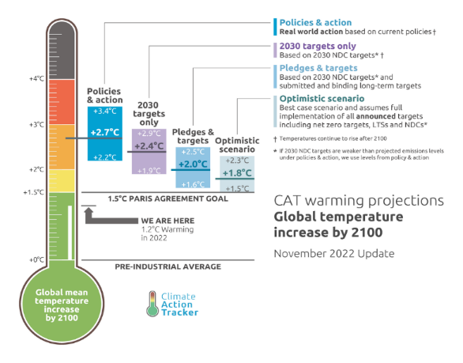

Figure 7: Climate Action Tracker (2022).

This is the main reason why public policies, apart from playing a crucial role in this issue, must recognize the different actors responsible for CO₂ emissions in order to apply specific solutions to these problems.

At the same time, we as citizens, although we can contribute by changing our lifestyles, considering with that alone we would achieve almost no impact, still we play a huge role in the sense of our power of influence through the vote, since the governments elected by us are those who have the tools to achieve a significant positive impact, and adjust our voting preference towards political actors capable of proposing realistic, feasible solutions and able to recognize the diversity of public policies that can be promoted in such a complicated topic, will achieve that little by little, these political actors try within their different ideologies to solve this issue in order not to lose votes.

It is also palpable that governments could be doing more, but for various reasons (some of which are explained in this research), they do not act because of the political lobbies that are generated around them, which is important in requiring governments to realistically redirect subsidies from the coal and gas industries towards investing in greener energies, as is often stated in this research. Trying to reach the technological evolutions will not be possible without a proper investment in that area, and governments must consider that the climate goals agreed for the upcoming years requires also applying new and original solutions with the greatest possible heaste.

As for possible problems to be considered in this research, apart from the fact that the implementation of policies depends very much on the country, its possibilities and economic contexts, or that countries such as Germany or Ukraine, for historical reasons, are reluctant to implement expansive nuclear energy policies, these problems are not so difficult to solve and are already being worked on effectively, but a clear challenge for the future in terms of applying these and other solutions to mitigate climate change is the situation of developing countries, since economic growth is the trend to which all countries aspire, and in order to reach the wealth of developed countries, the most trivial way would be to follow the steps once taken by those countries. This would mean multiplying pollution levels to unsustainable levels, but at the same time, on the face of it, seeking to halt the growth of developed countries.
It has been shown that economic growth brings with it a growth in CO₂ emissions, and this fact holds true today especially in those developed countries, and if we look at CO₂ emissions data for the year 2019, we can conclude that 63% of global CO₂ emissions come from low and middle-income countries, so seeking to escape poverty generates unavoidable pollution emissions, whereas they account for 84% of the global population⁹.
Between this and the fact that the correlation between population growth and CO₂ emissions is also positive, there are some drawbacks which must be considered, apart from what has already been mentioned in this research, when applying effective public policies.
That is another reason of why is important to invest in the future, and it is a fact that countries with different models of government, and from more democratic to more autocratic are applying policies with positive impact, but from the point of view of an underdeveloped country, being able to control birth and death rates to offer longer life expectancy with appropriate social welfare, involves promoting policies to achieve these objectives such as improving the human capital of its population through education (in fact, Sub-Saharan African countries are the most prominent in this problem)¹⁰, and in turn, it can be considered profitable to be able to invest in new technologies, and focus the industry of an underdeveloped country on specialising in the development of new technologies) and in turn, it can be considered profitable to invest in new technologies, and to focus an underdeveloped country's industry on specialising in an effective and green way of producing energy, in order to determine a different roadmap for achieving wealth as an underdeveloped country while being environmentally responsible. Still, this is an issue that requires close attention, as it is a very important determinant in considering global multilateral agreements.

Appendix

Necessary for showing a bit more in detail how some of the statements on this research have been reached:

1. According to data from the first figure, road transport was responsible for 11,9% of all greenhouse gas emissions in 2016, with 60% of those emissions coming from passenger trips in cars, motorcycles, and buses and 40% from goods transport on roads: "Household emissions are higher than those coming from all the vehicle transport" (RITCHIE et al., 2020).

When you multiply 49.4 billion tonnes of CO₂ equivalent by 11.9%, you get 5.88 billion tonnes of CO₂, and when you factor in 60% of passenger travel, you get 3.53 billion tonnes of CO₂.
2.35 billion tonnes of CO2 equivalence of road freight = 40%.

Residential buildings made up 10,9% of the total, and the energy was used to generate electricity for household heating, lighting, appliances, and other uses.

Houses released 5.390 million tons of CO₂ by multiplying 49.400 billion tons of CO2 equivalent by 10,9%.
As a result, in 2016 there were 5390 million tons of CO₂ emissions from residential buildings as opposed to 3530 million tons from vehicle transports.
2. Given that the average worldwide CO₂ emissions per person were roughly 5 tons in 2017, assuming a 72-year lifespan, this would add up to 360 tons of CO₂ emissions. However, this value varies widely between nations. In the meantime, the global energy industry generates 36 billion tons of CO₂ annually, or 73.2% of all greenhouse gas emissions. This is equivalent to 98.63 million tons per day, 4.11 million tons each hour, or 1141 tons per second.
For instance, the average US citizen released 16.2 tons of CO₂ in 2017, and if they committed their entire lives to reducing their carbon footprint, they would make up for 1.12 tons of emissions seconds worth of the emissions of the energy sector (RITCHIE et al. 2020).

3. Considering data from the World Bank rank of countries based on gross income per capita, we identify 4 groups: High-, upper-middle-, lower-middle and low income.

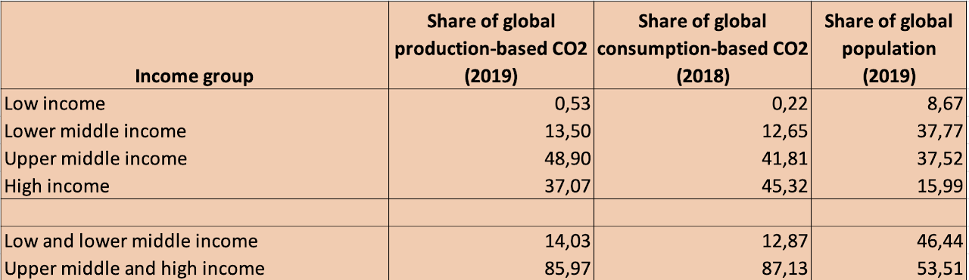

Figure 8: Hannah Ritche, OWID

Production-based emissions rather than consumption-based emissions are taken into account to eliminate data gaps since data for the first variable is not accessible for some nations because it necessitates a detailed inventory of traded products.
According to the analysis's table, there are two distinct groups: those with high and upper medium incomes, and those with low and lower middle incomes. When observing that these two groups have roughly the same amount of global population but that, at the same time, the largest disparities in economic growth are frequently seen in the second group, the following conclusion is valid: Their emissions differ significantly from one another.
Low-, lower-middle-, and upper-middle-income countries account for 84% of the world's population, however they account for just 53%, 13.5%, and 48.9% of the world's total production-based emissions.

References

- NORDHAUS, W. D. (2018): Projections and Uncertainties about Climate Change in an Era of Minimal Climate Policies. 10. (Heft 3). S. 333–360.
- ‌PHILIPPE AGHION, HEPBURN, C., TEYTELBOYM, A. & DIMITRI ZENGHELIS (2019): Path dependence, innovation and the economics of climate change. Elgar Online: The online content platform for Edward Elgar Publishing. S. 67–83.
- Yoichi Kaya and Keiichi Yokobori (1997): Environment, energy, and economy: Strategies for sustainability: https://archive.unu.edu/unupress/unupbooks/uu17ee/uu17ee00.htm#Contents
- ‌MCKIBBIN, W. J. & WILCOXEN, P. J. (2002): The Role of Economics in Climate Change Policy. 16. (Heft 2). S. 107–129.
- Air passengers carried, 2023. https://ourworldindata.org/grapher/air-passengers-carried?tab=chart&country=~OWID_WRL
- RITCHIE, H., ROSER, M. & ROSADO, P. (2020): CO2 and Greenhouse Gas Emissions. https://ourworldindata.org/emissions-by-sector#sector-by-sector-where-do-global-greenhouse-gas-emissions-come-from
- Global Fossil Fuel Subsidies Remain Large: An Update Based on Country-Level Estimates, 2019. https://www.imf.org/en/Publications/WP/Issues/2019/05/02/Global-Fossil-Fuel-Subsidies-Remain-Large-An-Update-Based-on-Country-Level-Estimates-46509
- ‌ENERGY SUBSIDIES – TOPICS - IEA (2021): Energy subsidies – Topics - IEA. https://www.iea.org/topics/energy-subsidies
- ‌Fossil Fuel Subsidies, 2019. https://www.imf.org/en/Topics/climate-change/energy-subsidies#Who%20Benefits%20from%20Energy%20Subsidies
- ‌CORINNE LE QUÉRÉ, PETERS, G. P., FRIEDLINGSTEIN, P., LIU, Y., JOSEP PEÑUELAS, DAVIS, S. J., JACKSON, R. B. & JONES, M. D. (2021): Fossil CO2 emissions in the post-COVID-19 era. 11. (Heft 3). S. 197–199.
- ‌KALOUSH, K., BILIGIRI, K., WHITE, P., GOLDEN, J., PHELAN, P. & LEE, H.-S. (o. J.): Assessment Tool to Estimate CO2 Emissions of Pavement Production and Construction.
- ‌ANDREW, R. M. (2019): Global CO2 emissions from cement production, 1928–2018. Earth System Science Data 11. (Heft 4). S. 1675–1710.
- ‌Food production is responsible for one-quarter of the world’s greenhouse gas emissions, 2019. https://ourworldindata.org/food-ghg-emissions
- ‌ALEKSANDRA ARCIPOWSKA, MANGAN, E., LYU, Y. & WAITE, R. (2019): 5 Questions About Agricultural Emissions, Answered. https://www.wri.org/insights/5-questions-about-agricultural-emissions-answered
- ‌RANGANATHAN, J., WAITE, R., SEARCHINGER, T. & HANSON, C. (2018): How to Sustainably Feed 10 Billion People by 2050, in 21 Charts. https://www.wri.org/insights/how-sustainably-feed-10-billion-people-2050-21-charts
- LYNCH, J. & PIERREHUMBERT, R. T. (2019): Climate Impacts of Cultured Meat and Beef Cattle. 3.
- ‌Reducing food’s environmental impacts through producers and consumers, 2019. https://www.science.org/doi/10.1126/science.aaq0216
- ‌RITCHIE, H. & ROSER, M. (2013): Land Use. https://ourworldindata.org/land-use
- ‌What are the carbon opportunity costs of our food?, 2021. https://ourworldindata.org/carbon-opportunity-costs-food
- ‌Carbon Pricing Dashboard | Up-to-date overview of carbon pricing initiatives, 2023. https://carbonpricingdashboard.worldbank.org/
- ‌The CAT Thermometer, 2022. https://climateactiontracker.org/global/cat-thermometer/
- ‌NEUKIRCH, M. (2022): Transition of Energy Systems: Patterns of Stability and Change. S. 19–47.
- ‌HENRI DELANGHE & UGUR MULDUR (2014): Research and Experimental Development (R&D) and Technological Innovation Policy. S. 1–6.
- ‌WOOLCOCK, S. (2011): European Union (EU) Trade Policy. S. 1–7.
- ‌PETER (2016): Energy Transitions. S. 1–24.
- KNODT, M. & JÖRG KEMMERZELL (2022): Energy Governance in Europe: Introduction. S. 3–16.
- JÖRG KEMMERZELL, BRUCH, N. & KNODT, M. (2022): Energy Governance in Europe: Country Comparison and Conclusion. S. 1289–1317.
- ANASTASIOS XEPAPADEAS (2008): Ecological Economics. S. 1–8.
- CHITNIS, M., SORRELL, S., DRUCKMAN, A., FIRTH, S. K. & JACKSON, T. (2014): Who rebounds most? Estimating direct and indirect rebound effects for different UK socioeconomic groups. 106. S. 12–32.

‌

1: see in the Appendix, second section.
ALEKSANDRA ARCIPOWSKA, MANGAN, E., LYU, Y. & WAITE, R. (2019): 5 Questions About Agricultural Emissions, Answered. ‌
UNITED NATIONS (2019): World population prospects 2019. 4 See Appendix, Section 1. 4: See Appendix, Section 1. 5 RITCHIE, H., ROSER, M. & ROSADO, P. (2020): CO2 and Greenhouse Gas Emissions. ‌ ‌ ‌
6 ANDREW, R. M. (2019): Global CO2 emissions from cement production, 1928–2018. Earth System Science Data 11. S. 1675–1710. ‌
7 LYNCH, J. & PIERREHUMBERT, R. T. (2019): Climate Impacts of Cultured Meat and Beef Cattle. 3. ‌
8: Sustainable Construction with Concrete: Is it Possible? https://www.buildwithrise.com/stories/sustainable-construction-with-concrete-is-it-possible 9: Fossil Fuel Subsidies. https://www.imf.org/en/Topics/climate-change/energy-subsidies#Who%20Benefits%20from%20Energy%20Subsidies ‌
10 The CAT Thermometer. https://climateactiontracker.org/global/cat-thermometer/ ‌

